UNIVERSITY INSTITUTE OF COMPUTING

Minor Project

( Based On MCA )

[ 20CAR-719ON ]

ON

Student Record Management System

Submitted by

KRISHNA KUMAR

UID: 20MCA1484

(Master of Computer Applications)

3r SEM

Under the Guidance of

Er. Prabhsharan Kaur (E4038)

( Assistant Professor department of computer science)

PROJECT TITLE : Student Record Management System

SELF DECLARATION

I the undersigned solemnly declare that the Minor Project “Student Record Management System” is based on my own work carried out during the course of our study under the supervision of Er. Prabhsharan Kaur . I assert the statements made and conclusions and drawn are an outcome of my research and work I further certify that.

- The work contained in the report is original and has been done by me under the general supervision of my supervisor.
- The work has not been submitted to any other Institution any other University
- We have followed the guidelines provided by the university in writing the report.

- Whenever we have used materials (data, theoretical analysis, and text) from other sources, we have given due credit to them in the text of the report and giving their details in the references.

Name : KRISHNA KUMAR

Roll No.: 20MCA1484

CERTIFICATE FROM THE SUPERVISOR

This is to certify that the work incorporated in the project report entitled “Student Record Management System” is a record of work carried out by Name: KRISHNA KUMAR Roll No./ Enrol. No.: 20MCA1484 under my guidance and supervision for the award of Degree of Master of Computer Application in the faculty of Department of Computer Engineering of Chandigarh University, Mohali, Punjab, India. To the best of my/our knowledge and belief the project report

I. Embodies and the work of the candidates themselves,

II. Has duly been completed,

III. Fulfils the requirement of the Ordinance relating to the Master degree of the University and is up to the desired standard both in respect of contents and language for being referred to the examiners.

Er. Prabhsharan Kaur

(GUIDE)

PROFF/SEMINAR CO-ORDINATOR

The project and work as mentioned above is Forwarded for examination and evaluation

Acknowledgement

My most extreme appreciation goes out to the Lord for the security, arrangement and wisdom He provided for me during the time of exploration.

This assignment would not have been finished without the direction and scholarly help of my administrator Er. Prabhsharan Kaur .

.

I thank all the staff of chandigarh University, at various times for the support and the confidence they have had in me.

I might likewise want to recognize my coaches and Teacher Er. Prabhsharan Kaur for having confidence in me.

Moreover, I might want to recognize my associates, specifically my schoolmates for the cooperation they exhibited during this excursion.

Earnest appreciation goes to the creators, respondents, and different establishments, for their collaboration, information, and experience shared.

At last, I recognize the pretended by my family, particularly my dad, for the monetary help. Also, my companion for her help, consolation, helping me what's more, among others.

Abstract

This review pointed toward building up, progress of Student Records Management System in chandigarh University. In particular, this review needed to find the information assortment of understudy records in Chandigarh University, to develop the effect of data security of understudy records, lastly, it was done to set up the improvement of mechanized data the executives of understudy Records In Chandigarh University. The review embraced a distinct plan, with a populace, an example testing techniques, for example, bunch examining, and Efficient Probabilistic information assortment. The information gathered was examined utilizing SPSS and Dominate Software. The finding shows that information assortment at Livingstone at present employments manual that is to say structure filling, verbal and later kept physically or in files,but they are intending to purchase a product for future. The specialist recommends that further examination ought to be directed in offices at Livingstone since understudies gather diverse data furthermore, put away in spots like enrollment and among others.

Table of contents

Chapter 1: Introduction………………………………………9
Background……………………………………………………………………………………
Objectives……………………………………………………………………………………..
Purpose,……………………………………………………………………………………….
Scope…………………………………………………………………………………………..
Applicability……………………………………………………………………………………
Organization of Report………………………………………………………………………..

Chapter 2: System Analysis…………………………………
Identification of Need…………………………………………………………………………
Preliminary Investigation……………………………………………………………………..
Feasibility Study………………………………………………………………………………..
Project Planning………………………………………………………………………………..
Project Scheduling (PERT Chart and Gantt Chart both)…………………………………..
Software requirement specifications (SRS)…………………………………………………….
Software Engineering Paradigm applied………………………………………………….
Data models (like DFD), Control Flow diagrams, State Diagrams/Sequence diagrams, Entity Relationship Model, Class Diagrams/CRC Models/Collaboration Diagrams/Use-case Diagrams/Activity Diagrams depending upon your project requirements

Chapter 3: System Design………………………………18
Modularization details…………………………………………………………………..
Data integrity and constraints…………………………………………………………..
Database design, Procedural Design/Object Oriented Design……………………….
User Interface Design……………………………………………………………………….
Test Cases (Unit Test Cases and System Test Cases)………………………………

Chapter 4: Coding………………………………………….36
Complete Project Coding………………………………………………………………….
Comments and Description of Coding segments
Standardization of the coding…………………………………………………………….
Code Efficiency……………………………………………………………………………..
Error handling………………………………………………………………………………..
Parameters calling/passing………………………………………………………………..
Validation checks…………………………………………………………………………….

Chapter 5: Testing……………………………………………
Testing techniques and Testing strategies used…………………………………………

Testing Plan used…………………………………………………………………………..
Test reports for Unit Test Cases and System Test Cases……………………………..
Debugging and Code improvement………………………………………………………
System Security measures (Implementation of security for the project developed)…
Database/data security……………………………………………………………………..
Creation of User profiles and access rights……………………………………………..
Reports (sample layouts should be placed-If possible)………………………………..

Chapter 6: Documentation…………………………………45
Cost Estimation of the Project along with Cost Estimation Model……………………
Pre-Requisite for project Installation……………………………………………………..
Comparative Analysis………………………………………………………………………
Negative Results…………………………………………………………………………….

Chapter 7: Conclusion and Future Scope……………….51
Conclusion…………………………………………………………………………………
Future scope and further enhancement of the Project……………………………….
Bibliography(APA Format) Appendices (if any-Daily report) Glossary………………
Plagiarism and Grammar report…………………………………………………………

INTRODUCTION

The mini-project “Student Record System Project in C” is a console application using the C programming language and This Project compiled in Code Blocks with the GCC compiler. In this console base . application, I can do basic Student Record tasks like adding the student info, view the added student, search the students.
Also to increase the readability, I have broken the application in different functions and Each function of the project extensively use in the file handing

function, so it is also a great project to understand file handling. The fundamental technique includes plausibility study, information assortment, framework investigation and plan, developingand executing Understudy Data set Administration Framework. The information considered important to assemble thesystem were gathered and dissected. The approach is vital to guarantee that the newsystem would offer advantages to the proposed learning establishment.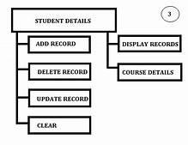
Background
Chandigarh university was opened on a rented grounds close the chandigarh, punjab, roughly 25 kilometers , by street, chandigarh , the capital and biggest city

in the country chandigarh University intends to possess this rented grounds for a time of as long as three years while at the same time developing a super durable grounds. sections of land of land have effectively been bought right outside of Mbale district on the principle street that goes west chandigarh. A grounds end-all strategy has been created, and raising support is occurring for inevitable development of LIU's long-lasting grounds on this site. Chandigarh University Strategic Plan 2009-2014 was finished December , 2012 and submitted to the UGC determined to be sanctioned as a completely authorize college by the India government. The initial phase in this cycle was refined December when the NCHE gave Chandigarh University a Letter of Provisional Authority. This permitted Chandigarh University to start purchasing property, get ready educational plans, employ workforce and staff and set up banking and other business undertakings. Chandigarh University accepted its Provisional License from the india . This pre-arranged the way for the primary understudy admission in January, 2012. Presently Chandigarh University is working under the direction of the toward fitting the bill for a full college contract. In Chandigarh University Campus, data of the board for understudy records are recorded each semester, and toward the year's end, the rundown is finished. The recording is finished by the secretary, recorder and enlistment office. Most eastern colleges deal with the understudy records, Livingstone worldwide college with the most recent Technology/trend

setting innovation, actually use paper based strategies during recording by which it requires extended periods of time just to catch one's data from paper into framework but then they have day by day exercises to do . Also, the understudies once in a while are counted utilizing the enrolled understudies or counting; this framework is described by manual structure filling to get bio-information of the understudies, and later exchange of the data from manual information, catch structures to mechanized datasheets, subsequently, it has prompted an inordinate number of errors to the last removal of some understudy's structures thus prompting disarray at the hour of contrasting the outcomes. The primary benefit of paper based frameworks is that papers are effectively human auditable and capacity and can be put away appropriately without the infection influencing them, concurring (Henry, 1988). Anyway the detriments overweighs the weakness as, for example the need to print the record of the understudy when it is in paper framework, it eases back the framework, unyielding. 4 Over the past semesters, there have been various understudy spectators who have recommended the board associations ought to present electronic catching, putting away at scholastic division or enlistment office. This will improve on catching and putting away of information for an extensive stretch of time

Purpose of the Study

The purpose of the study is to establish the impact of management information system on maintenance of student records in University.

OBJECTIVE

The review will base on the accompanying targets; I. Effect of mechanized information assortment on upkeep of understudy records in Chandigarh university
ii. Effect of mechanized data insurance (MIS) on upkeep understudy records
iii. Effect of mechanized records the board (MIS) on upkeep of understudy records'. The primary goal is to foster a hearty Student Database Management System for understudy Programme.Specific Objectives

To test and validate the system

Objective of this project is to build a student database system that will store records of student. The system maintains records of students, the courses and modules on which they are registered and the outcome of their study the application is distributed. Application because the data is stored centrally by the registration database administer that accessed by academic staff and administrators across the Students.
Students also access the system to view their results and the real system would be service oriented and would expose some of its functionality as a set of services which could be consumed by other application.

SCOPE OF THE PROJECT
Student record management system is The main objective is to develop a strong Student direction System for student Programme.Specific Objectives To

implement the systemii. to check and validate the system Objective of this project is to make a student information system which will store records of student. The system maintains records of scholars, the courses and modules on that they're registered and the result of their study the appliance is distributed. Application as a result of the info is hold on centrally by the registration information administer that accessed by tutorial employees and directors across the Students. Students conjointly access the system to look at their results and therefore the real system would be service bound and would expose a number of its practicality as a collection of services that may be consumed by alternative application.
Applicability
According to Jonelle (2002) noted that management information system is vital in assisting executives and the general workforce in performing any tasks related to the processing of information and Satyanaraya (2009) said that , management information system in maintenance student records in university helps to provide accurate and timely information necessary to facilitate the decision-making process and enable the organizations planning, control, and operational functions to be carried out effectively.

Chapter 2: System Analysis

FEASIBILITY STUDY

Feasibility concentrates on expect to equitably and sanely reveal the qualities and shortcomings of the current framework or proposed adventure. In its least difficult term, the two models to pass judgment on attainability are cost required and worth to be achieved. All things considered, a very much planned achievability study ought to give recorded foundation of the venture. For the most part, plausibility studies go before specialized turn of events and task execution. The appraisal of possibility study depends on the accompanying variables:
1) Technical Feasibility
2) Operational Feasibility
SPECIALIZED FEASIBILITY Generally, practicality studies go before specialized turn of events and venture execution. The evaluation depends on a framework necessity as far as Input, Processes, Output, Fields, Programs, and Procedure. This can be measured as far as volumes of information, patterns, recurrence of refreshing, and so on, to gauge if the new framework will perform sufficiently

Innovative practicality is done to decide the capacity, as far as programming, equipment, work force and skill, to deal with the fulfillment of the undertaking.

FUNCTIONAL FEASIBILITY- Operational practicality is a proportion of how well a proposed framework tackles the issues, and makes the most of the chances distinguished during degree definition and how it fulfills the prerequisites recognized in the necessities investigation period of framework advancement. The functional attainability of the framework can be checked

as it takes care of the issues and diminishes the intricacies happening in the paper-pencil test.

FINISH OF FEASIBILITY STUDY- 1) Technical Feasibility: The framework can be executed utilizing PC programming and equipment. 2) Operational Feasibility: The framework proficiently works and lessens manual calculation and season of preparing, diminishing expense of administrative work and human mistakes.

Software requirements:

Code Blocks

GCC compiler

C programming language

5.3 Hardware Requirements:
- Processor: Intel Pentium 4 or more
- Ram: 1 GB or more
- Hard disk: 40 GB hard disk recommended for the primary partition.

Chapter 3: System design

The DFD takes an info cycle yield perspective on a framework.That is, information objects stream into the product, are changed by the preparing components, and resultant information objects stream out of the product. Information object are addressed by circles. The DFD is addressed by marked bolts and changes are addressed in a progressive manner. The main DFD addresses the framework all in all. Resulting information stream charts furnish expanding point of interest with each ensuing information stream charts give expanding point of interest with each ensuing level
DFD
A Data Flow Diagram (DFD) is a graphical portrayal of the "stream" of Student Record System. An information stream graph can likewise be utilized for the perception of Data Processing DFD shows the cooperation between the framework and outside substances. This setting level DFD is then, at that point "detonated" to show more detail of the framework being displayed. A DFD addresses stream of information through a framework. Information stream graphs are usually utilized during issue examination. It sees a framework as capacity that changes the given contribution to required yield. Development of

information through the various changes or cycles in the framework are displayed in Data Flow Diagram of Fig

The plan of the understudy data the executives framework incorporates the plan of the landing page which gives the way to every one of the understudies, staff and other client to get to the SRMS.

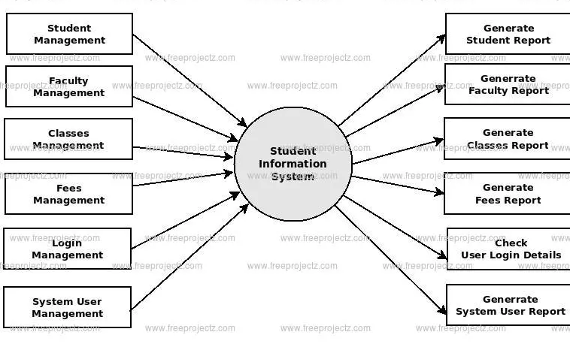

Zero level data flow digram
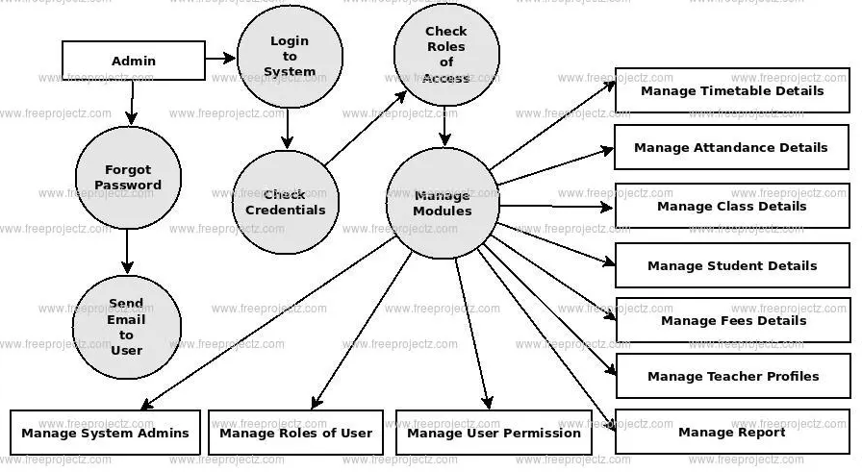
First level data flow digram

DETAILED FLOW GRAPH
The point by point stream chart is displayed in The plan of the understudy data the executives framework incorporates the plan of the landing page which gives the way to every one of the understudies, staff and other client to get to the SRMS. Each client of the SRMS has an interesting username and secret phrase given by the website admin of the school. The landing page basically contains a login structure through which another client can enroll, or a current client can login to the framework by entering the username and secret word given by the website admin
Modularization details
Framework DESIGN AND IMPLEMENTATION To plan a framework that could work with the catch, stockpiling and recovery of clients' room records, the information gathered was investigated to decide the most ideal way it could be put away and recovered through utilizing the Entity Relationship Model and Data Flow Graphs and hence the fundamental necessities for the plan of the understudy records the executives framework are: Every client ought to have their own character Login office. User can refresh his/her own data and can see the notification, results, arrangement and test area refreshes and so on Faculty,

arrangement and test areas can refresh any of the data.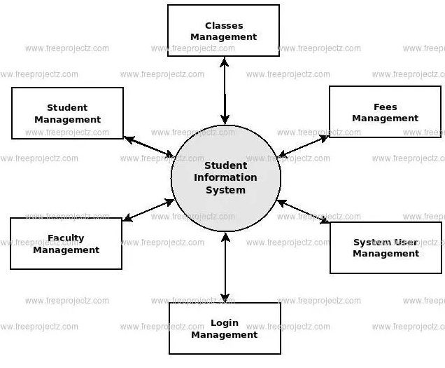
Second data flow digram

Data Design
The chart beneath shows the element Relationship outline that shows the essential and the unfamiliar limitations. Any reasonable person would agree that data set assume a basic part in practically all regions where PCs are utilized, including business, electronic trade, designing, medication, law, training, and library science. Along these lines, a data set is assortment of a connected information. An information base has the accompanying implied properties: A data set addresses some part of this present reality, now and then called the miniworld or the Universe Of Discourse (UOD) changes to the small scale world are reflected in the data set. An information base is an intelligently rational assortment of information with some inborn importance. An arbitrary arrangement of information can't accurately be alluded to as a data set. A data set is planned, constructed, and populated with information for a particular reason. It is an expected gathering of clients and some biased application which these clients are intrigued.

USER INTERFACE DESIGN AND SCREENSHORT
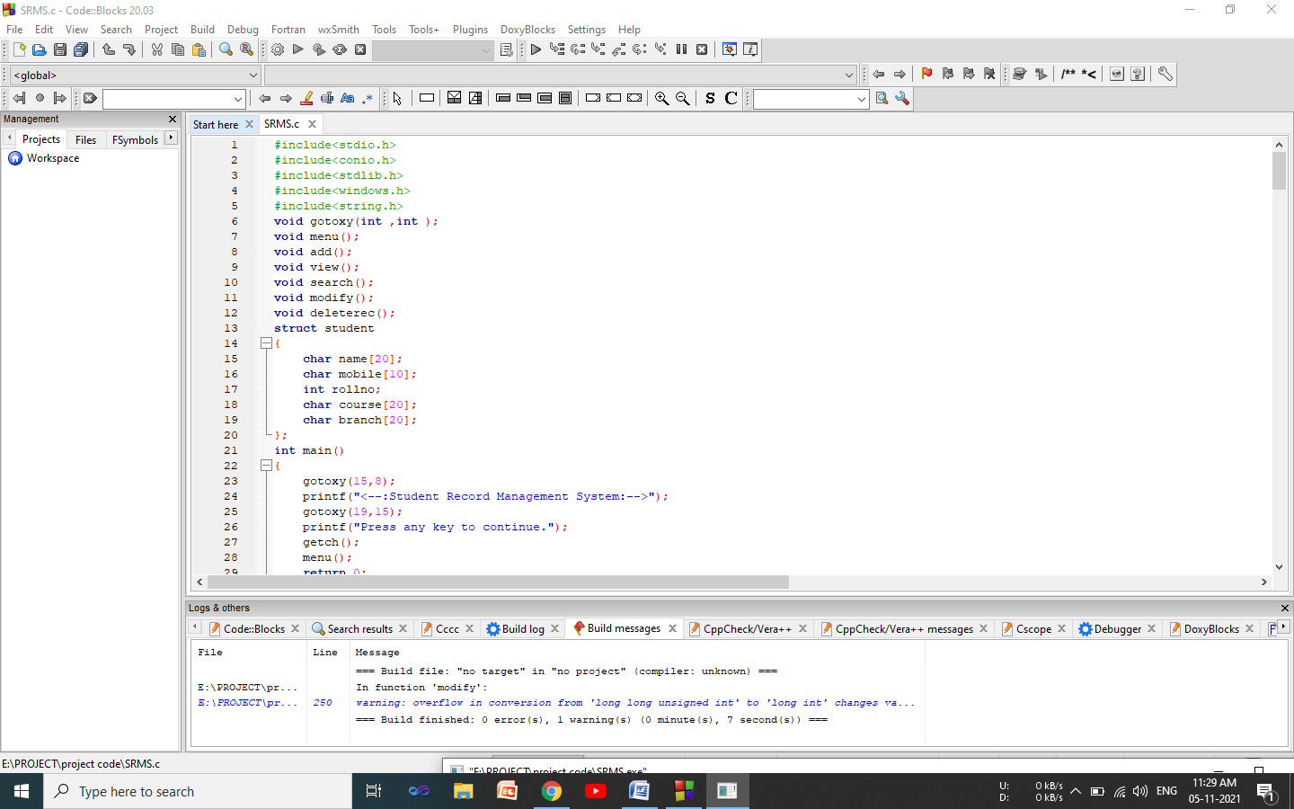
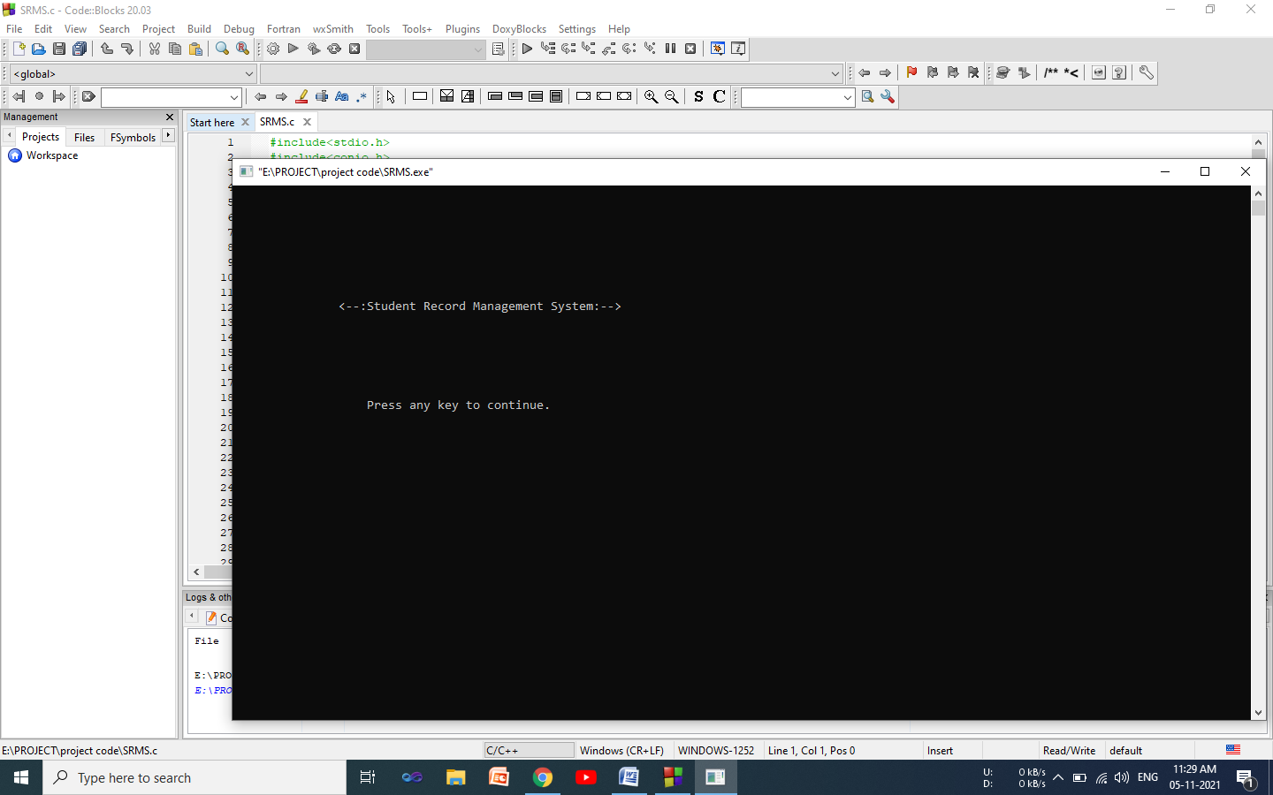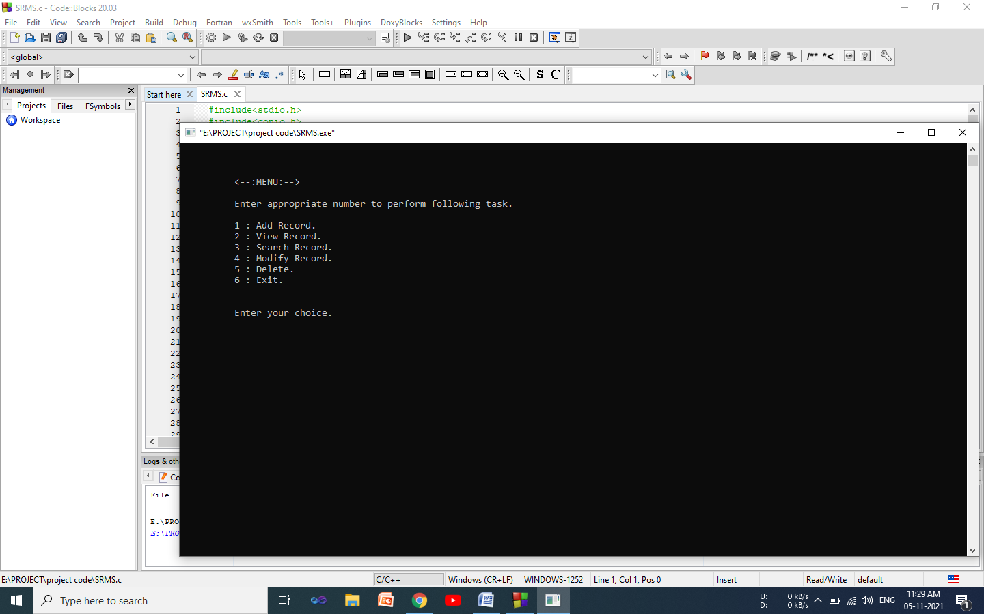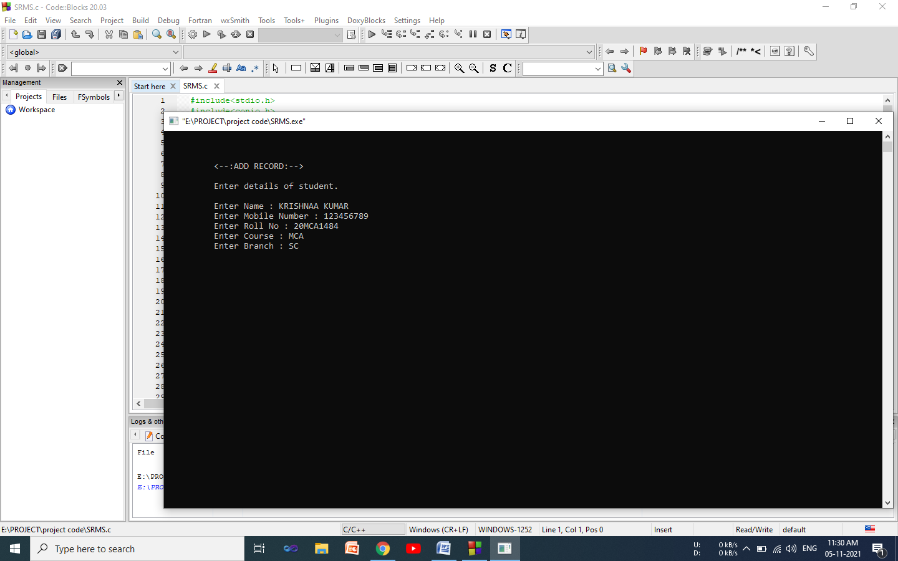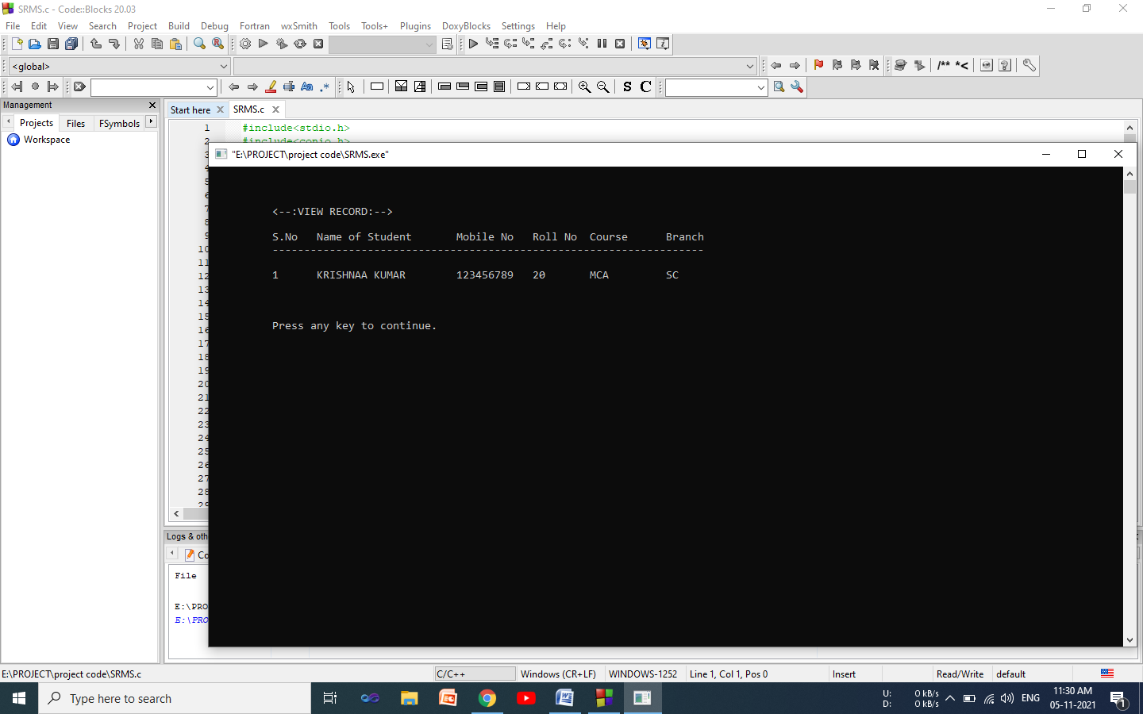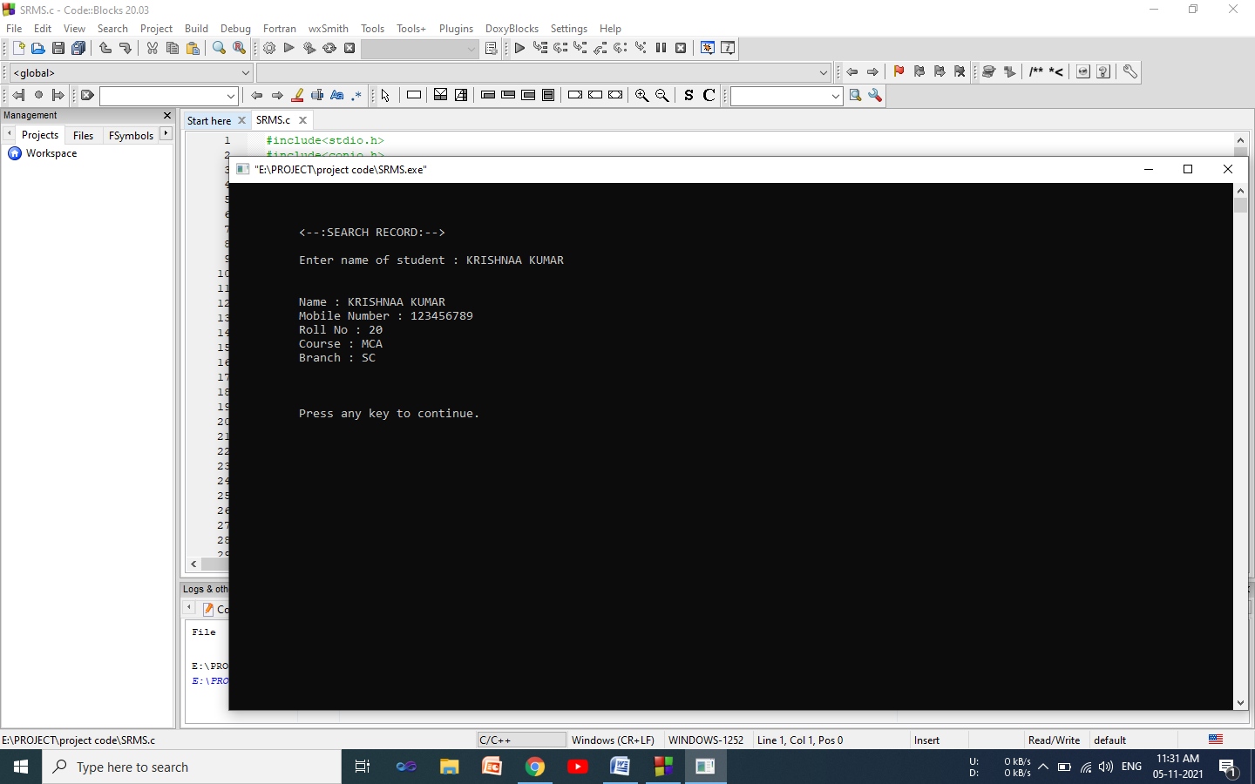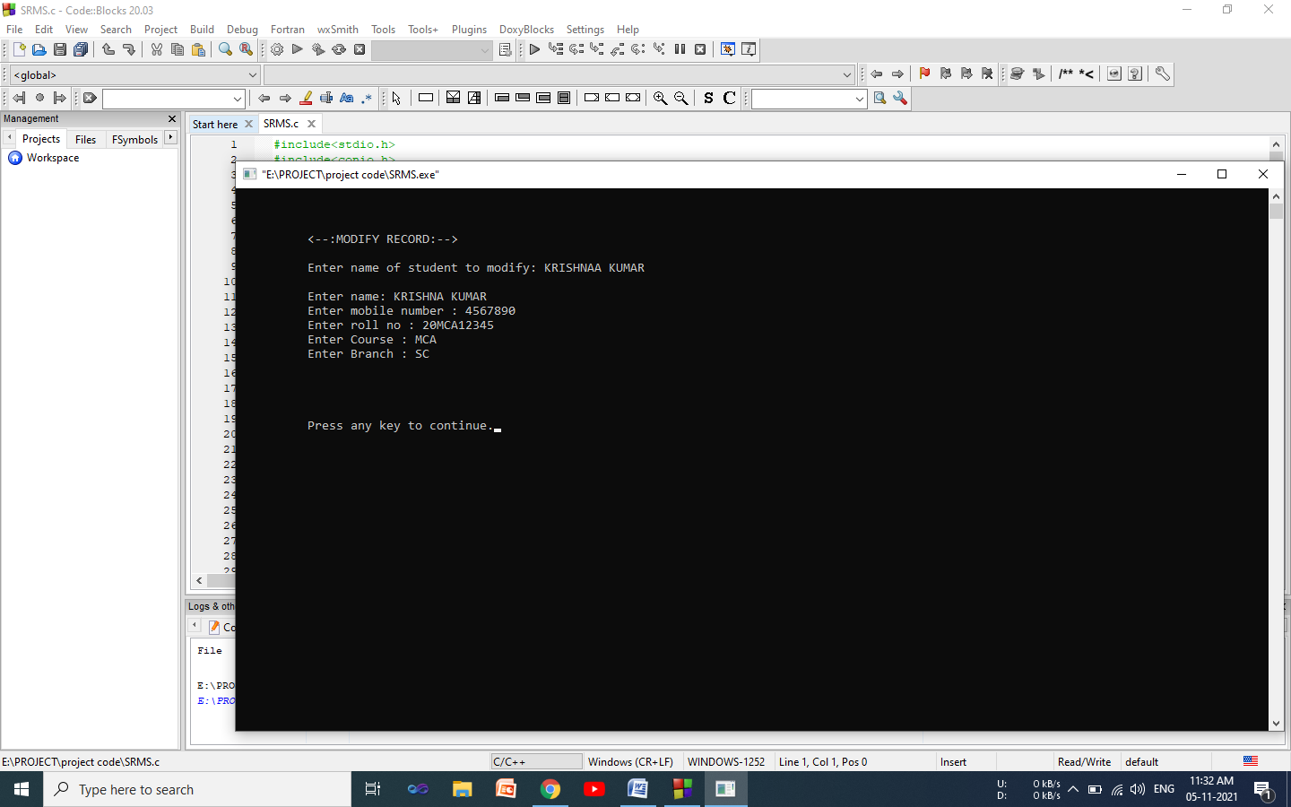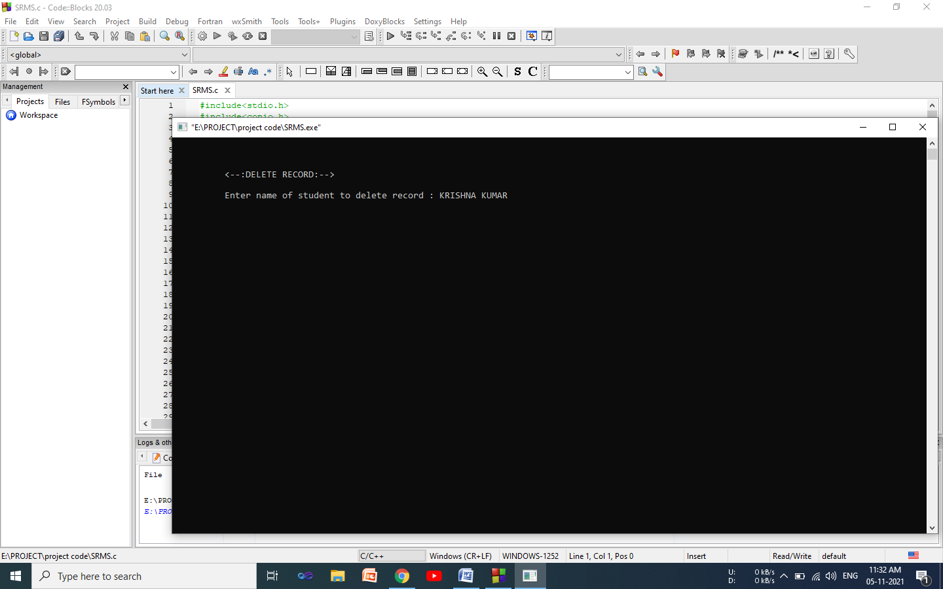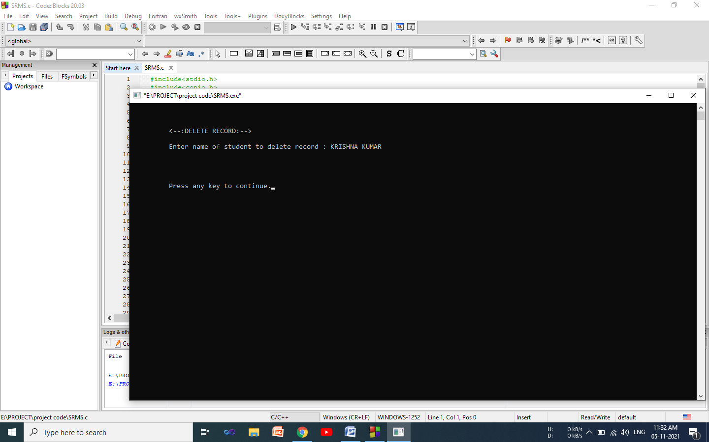

Chapter 3: coding

#include<stdio.h>
#include<conio.h>
#include<stdlib.h>
#include<windows.h>
#include<string.h>
void gotoxy(int ,int );
void menu();
void add();
void view();
void search();
void modify();
void deleterec();
struct student
{
char name[20];
char mobile[10];
int rollno;
char course[20];
char branch[20];
};
int main()
{
gotoxy(15,8);
printf("<--:Student Record Management System:-->");
gotoxy(19,15);
printf("Press any key to continue.");
getch();
menu();
return 0;
}
void menu()
{
int choice;
system("cls");
gotoxy(10,3);
printf("<--:MENU:-->");
gotoxy(10,5);
printf("Enter appropriate number to perform following task.");
gotoxy(10,7);
printf("1 : Add Record.");
gotoxy(10,8);
printf("2 : View Record.");
gotoxy(10,9);
printf("3 : Search Record.");
gotoxy(10,10);
printf("4 : Modify Record.");
gotoxy(10,11);
printf("5 : Delete.");
gotoxy(10,12);
printf("6 : Exit.");
gotoxy(10,15);
printf("Enter your choice.");
scanf("%d",&choice);
switch(choice)
{
case 1:
add();
break;

case 2:
view();
break;

case 3:
search();
break;

case 4:
modify();
break;

case 5:
deleterec();
break;

case 6:
exit(1);
break;

default:
gotoxy(10,17);
printf("Invalid Choice.");
}
}
void add()
{
FILE *fp;
struct student std;
char another ='y';
system("cls");

fp = fopen("record.txt","ab+");
if(fp == NULL){
gotoxy(10,5);
printf("Error opening file");
exit(1);
}
fflush(stdin);
while(another == 'y')
{
gotoxy(10,3);
printf("<--:ADD RECORD:-->");
gotoxy(10,5);
printf("Enter details of student.");
gotoxy(10,7);
printf("Enter Name : ");
// gets(std.name);///???
gets(std.name);
gotoxy(10,8);
printf("Enter Mobile Number : ");
gets(std.mobile);
gotoxy(10,9);
printf("Enter Roll No : ");
scanf("%d",&std.rollno);
fflush(stdin);
gotoxy(10,10);
printf("Enter Course : ");
// gets(std.course);///???
gets(std.course);
gotoxy(10,11);
printf("Enter Branch : ");
gets(std.branch);
// gotoxy(10,12);
// printf("Enter Father's Name : ");
// gets(std.fathername);
fwrite(&std,sizeof(std),1,fp);
gotoxy(10,15);
printf("Want to add of another record? Then press 'y' else 'n'.");
fflush(stdin);
// another = getch();///???
another = getch();
system("cls");
fflush(stdin);
}
fclose(fp);
gotoxy(10,18);
printf("Press any key to continue.");
getch();
menu();
}
void view()
{
FILE *fp;
int i=1,j;
struct student std;
system("cls");
gotoxy(10,3);
printf("<--:VIEW RECORD:-->");
gotoxy(10,5);
printf("S.No Name of Student Mobile No Roll No Course Branch");
gotoxy(10,6);
printf("--------------------------------------------------------------------");
fp = fopen("record.txt","rb+");
if(fp == NULL){
gotoxy(10,8);
printf("Error opening file.");
exit(1);
}
j=8;
while(fread(&std,sizeof(std),1,fp) == 1){
gotoxy(10,j);
printf("%-7d%-22s%-12s%-9d%-12s%-12s",i,std.name,std.mobile,std.rollno,std.course,std.branch);
i++;
j++;
}
fclose(fp);
gotoxy(10,j+3);
printf("Press any key to continue.");
getch();
menu();
}
void search()
{
FILE *fp;
struct student std;
char stname[20];
system("cls");
gotoxy(10,3);
printf("<--:SEARCH RECORD:-->");
gotoxy(10,5);
printf("Enter name of student : ");
fflush(stdin);
gets(stname);
fp = fopen("record.txt","rb+");
if(fp == NULL){
gotoxy(10,6);
printf("Error opening file");
exit(1);
}
while(fread(&std,sizeof(std),1,fp ) == 1){
if(strcmp(stname,std.name) == 0){
gotoxy(10,8);
printf("Name : %s",std.name);
gotoxy(10,9);
printf("Mobile Number : %s",std.mobile);
gotoxy(10,10);
printf("Roll No : %d",std.rollno);
gotoxy(10,11);
printf("Course : %s",std.course);
gotoxy(10,12);
printf("Branch : %s",std.branch);
}
}
fclose(fp);
gotoxy(10,16);
printf("Press any key to continue.");
getch();
menu();
}
void modify()
{
char stname[20];
FILE *fp;
struct student std;
system("cls");
gotoxy(10,3);
printf("<--:MODIFY RECORD:-->");
gotoxy(10,5);
printf("Enter name of student to modify: ");
fflush(stdin);
gets(stname);
fp = fopen("record.txt","rb+");
if(fp == NULL){
gotoxy(10,6);
printf("Error opening file");
exit(1);
}
rewind(fp);
fflush(stdin);
while(fread(&std,sizeof(std),1,fp) == 1)
{
if(strcmp(stname,std.name) == 0){
gotoxy(10,7);
printf("Enter name: ");
gets(std.name);
gotoxy(10,8);
printf("Enter mobile number : ");
gets(std.mobile);
gotoxy(10,9);
printf("Enter roll no : ");
scanf("%d",&std.rollno);
gotoxy(10,10);
printf("Enter Course : ");
fflush(stdin);
gets(std.course);
gotoxy(10,11);
printf("Enter Branch : ");
fflush(stdin);
gets(std.branch);
fseek(fp ,-sizeof(std),SEEK_CUR);
fwrite(&std,sizeof(std),1,fp);
break;
}
}
fclose(fp);
gotoxy(10,16);
printf("Press any key to continue.");
getch();
menu();
}
void deleterec()
{
char stname[20];
FILE *fp,*ft;
struct student std;
system("cls");
gotoxy(10,3);
printf("<--:DELETE RECORD:-->");
gotoxy(10,5);
printf("Enter name of student to delete record : ");
fflush(stdin);
gets(stname);
fp = fopen("record.txt","rb+");
if(fp == NULL){
gotoxy(10,6);
printf("Error opening file");
exit(1);
}
ft = fopen("temp.txt","wb+");
if(ft == NULL){
gotoxy(10,6);
printf("Error opening file");
exit(1);
}
while(fread(&std,sizeof(std),1,fp) == 1){
if(strcmp(stname,std.name)!=0)
fwrite(&std,sizeof(std),1,ft);
}
fclose(fp);
fclose(ft);
remove("record.txt");
rename("temp.txt","record.txt");
gotoxy(10,10);
printf("Press any key to continue.");
getch();
menu();
}
void gotoxy(int x,int y)
{
COORD c;
c.X=x;
c.Y=y;
SetConsoleCursorPosition(GetStdHandle(STD_OUTPUT_HANDLE),c);
}

Chapter 5: Testing

Testing is something beyond investigating. The reason for testing can be quality confirmation, check and approval, or dependability assessment. Accuracy testing and unwavering quality testing are two significant spaces of testing. Programming testing is a compromise between financial plan, time and quality

Software Testing

Programming testing is the most common way of executing a program or framework with the goal of discovering mistakes. Or on the other hand, it includes any action pointed toward assessing a characteristic or limit of a program or a framework and establishing that it meets its necessary outcome. Programming isn't not normal for other actual cycles where sources of info are gotten and yields are

delivered. Where programming contrasts is in the way wherein it fizzles. In contrast to most actual frameworks, the majority of the deformities in programming are plan mistakes, not assembling absconds.

11.2 Usability testing

Under Usability Testing, User-neighborliness check is finished. The application stream is tried to know whether another client can comprehend the application effectively or not, Proper assistance recorded if a client stalls out anytime.

11.3 Install/Uninstall testing

Tried for full, incomplete, or redesign introduce/uninstall measure on various working frameworks under various equipment, programming climate.

11.4 Recovery testing

Testing how well a framework recuperates from crashes, equipment disappointments, or other cataclysmic issues.

11.5 Compability testing

Testing how well programming acts in a specific equipment/programming/operatingsystem/networkenvironment and various blends of above.

11.6 System testing

Whole framework is tried according to the prerequisites. Discovery type testing that depends on by and large prerequisites particulars, covers all consolidated pieces of a framework. The framework will be tried by running it to see, in case it is accomplishing what it will do.

11.7 End-to-end testing

Like framework testing includes testing of a total application climate in a circumstance that copies realworld use, for example, associating with an information base, utilizing network interchanges, or collaborating with other equipment, applications, or frameworks if suitable.

System Validation

It will be approved by

i. Calling on the understudies who are the fundamental clients of the framework to utilize the framework and see whether it truly accomplishes their assumptions 62

ii. ii. Deciding approval exercises that is, subtleties that will be needed for every one of the means in the approval interaction.

Chapter 7: Conclusion and Future Scope

Introduction

This part presents the conversation of discoveries, ends, and proposals emerging from the review targets which where; to develop information assortment, data security, enhance records the board (MIS) on upkeep of
understudy records'. At the finish of the conversation are the decisions about the review lastly, the proposals for additional exploration.

Discussions of the Findings

Under this part, various investigations are introduced that are either on the side of the discoveries or are in opposition to the discoveries. This has helped in coming to the end result of the study. The conversations are introduced beneath under every evenhanded.

Computerized Data Collection and Student Records

From the discoveries in part four, it was noticed that larger part of the respondents concurred that there's an effect of automated information

assortment on support of understudy Records. It is seen with the level of both unequivocally concur in addition to concur with the level of 65.7%. In

reference to Sharapova (2014) who clarified that all copies, different passages and insignificant papers were eliminated; remaining papers were checked for the data of interest.( D. I. (2002). Electronic Data Collection and Analysis. Electronic Data Assortment and Analysis. Recovered June 12, 2016, from http://www.public.asu.edu/~ferigabi/

Computerized Information Protection and Student Records

The Findings under this genuine demonstrated that the respondents solid concur that Different passwords/chronic numbers are utilized for security of the understudy records to get to the data effectively for ID and recording displayed with the level of 80%. Regarding W. K. Takramah, W. K., Atiwoto. (2015)., Student Database System for Advanced education: America Diary of Software Engineering and Applications. Vol. 4, No. 2, pp.23-34 clarified that understudy records ought to be ensured through

keeping the data in different media gadgets including penmanship, print microfilm, PC's principle memory, attractive tape, tape, circle or diskette, and should be given various passwords and identifiers for simple access, D. I. (2002). Modernized Data Collection and Analysis. Modernized Data

Assortment and Analysis. Recovered NOV 2021 from

Computerized Information Management and Student Records

The Findings under this genuine demonstrated that the respondents solid concur that Student Records are very much reported to be utilized for additional examinations and references as displayed with the level of 80%. Nonetheless, from the meetings one said that "They keep the understudy records in documents for references and further use or proof". Hence, from my perception, they keep documents of the understudies physically and further use. Concerning understudy records manual arranged by University of South Florida(Office of the recorder , the creation and support of records

identifying with the understudies of an establishment are fundamental to overseeing, giving , controlling the understudy scholastic advancement
furthermore, estimating their accomplishment both foundation after they leave the establishment henceforth, the understudy record should be recognizable or identifiers that identify with an understudy incorporate name, understudy ID, address , relative names a rundown of individual attributes Accordingly, understudy records ought to be kept up with in different media including penmanship, print microfilm, PC's primary

memory, attractive tape, tape, plate or diskette. As per Wisdom Kwami Takramah, Wisdom Kwasi Atiwoto. Understudy Database Framework for Higher Education: A Case Study at CHANDIGARH UNIVERSITY

Conclusion

From the discoveries and the conversation, the review makes the accompanying ends: For true one, the specialist reaches the resolution

there is need to develop the information assortment since the college is utilizing manual procedure for working one for every one understudy that devours time. Also, the analyst reached the resolution that the understudy records should be recognized distinctively for simple recovery and openness for development on the straightforwardness. From the examination of the exploration (meetings and poll), it apparent that understudy records are kept with just a single individual (recorder) where the remainder of the administration are not sure how the data is ensured and distinguished, hence there's need for straightforwardness furthermore, sharing of the passwords for better administration of the records particularly when one individual vanishes.

Efficiency and productivity

This examination was embraced with the principle objective to develop the understudy records the executives framework from the scholarly division, and permits the chairman to rapidly to catch and record them to the division to offices, dispose of mistakes brought about by messy penmanship, and furthermore empower the recovery of the set of experiences from the framework. This framework has had the option to

further develop time taken in the obtaining, catching strolling in office, clog in office and among others, recover information put away in the information stores for example for changes. The way that information is effectively recovered, time wastage is diminished and clients are served rapidly. This enhances the quantity of clients served in a specific time and additionally builds the benefits of the hotel.
This framework requires less labor to work at the pausing and gathering divisions than the recently utilized manual framework on the grounds that the time taken to recover information is on normal not exactly the time recently taken. The framework additionally requires less labor to

oversee authentic records since it's mechanized.

Accuracy

This framework expanded on the precision in various regions: through information approval confirmation methods, the framework controls human blunders to a base. Since the information is approved as it is entered human blunders are significantly decreased.

Limitations

The significant limit of the framework is that, however handling has been mechanized, input to the framework is as yet manual. This implies that not every one of the benefits of a completely electronic framework have been completely accomplished.
Subsequently, data is a fundamental instrument many schools and other association use to advance dynamic. Huge measure of understudy's information are created either physically or electronically on everyday schedule. At the point when populace of understudy in a school is not exactly 100, the manual framework can work impeccably however it isn't the best technique for overseeing records of understudies. The manual and crumbled electronic frameworks have various weaknesses since these

techniques for catching and overseeing information about understudies are inclined to information irregularity, information repetition, hard to refresh and keep up with information, awful security, troublesome

to force imperative on different information record and hard to reinforcement. A coordinated understudy information base framework gives pragmatic answers for address issues related with manual framework. To evaluate the presentation of the school and understudies extra time, there is the need to use past records of understudies with practically no missing information. The mechanized understudy data framework which catches and keeps up with longitudinal information of understudies would give a precise and dependable information about current and past understudies. The framework is liberated from mistakes and exceptionally proficient and less tedious because of the consideration taken to foster it. All the periods of programming improvement cycle are utilized and it is advantageous to express that the framework is extremely intense. Arrangements made for future improvement in the framework.
Plagiarism and Grammar report
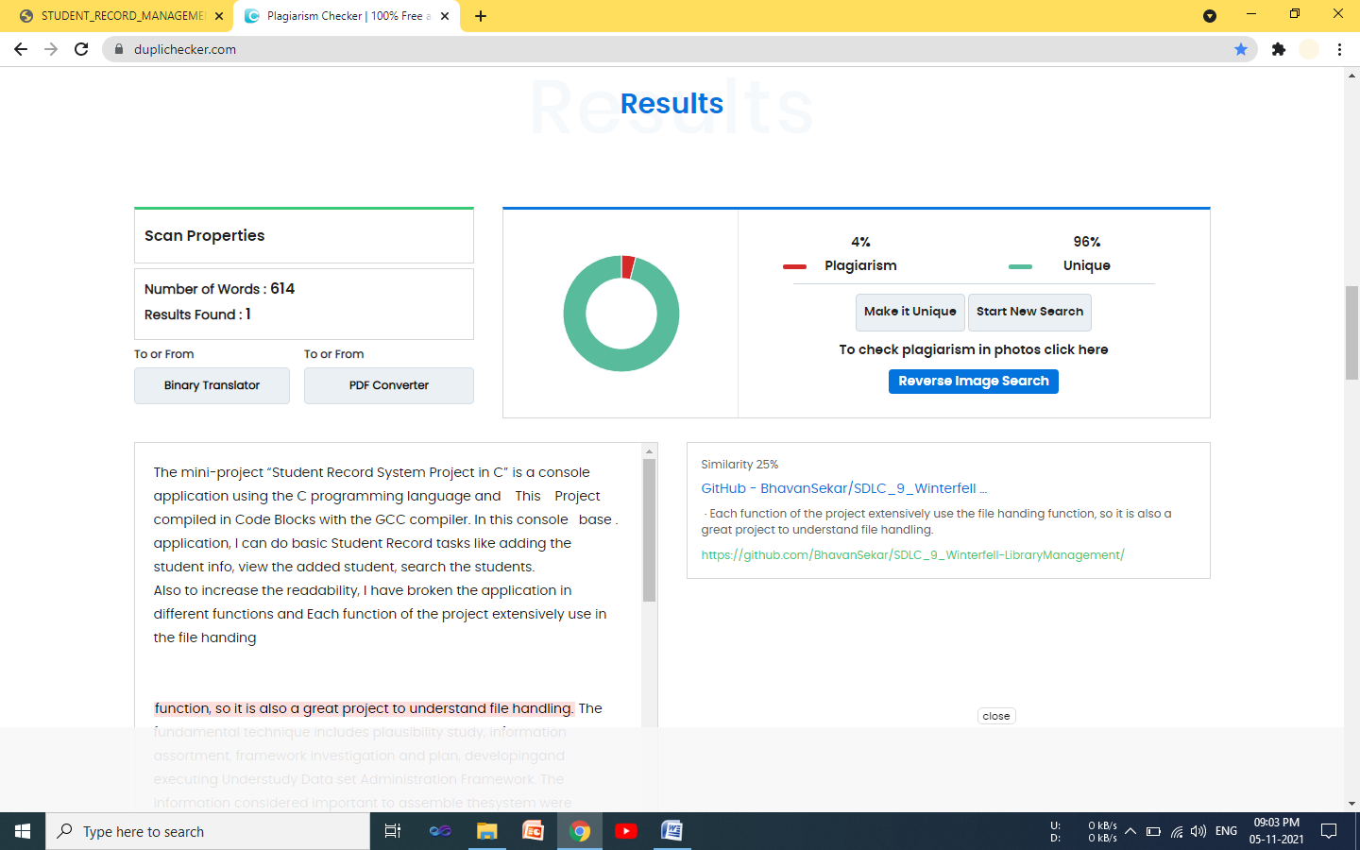

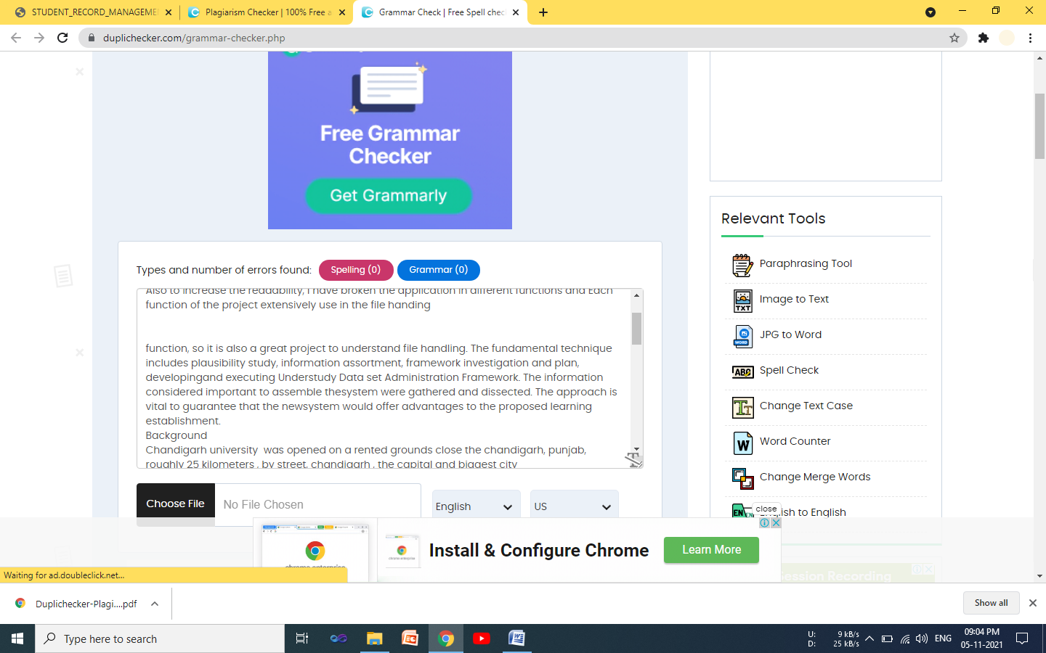

12. References as per APA formate

Soita,R(2016). Students Record Management System Project. Retrieved from

https://www.academia.edu/28742043/Students_Record_Management_System_Project_By_Soita_Reuben/

AR.C(2021). Student Record Management System with full project & source code, Retrieved from

https://codecanyon.net/item/student-management-system-full-project-with-source-code/21620970

2827 Eudra, L. (2001). The rules governing medicinal products in the European union . Computerized Systems, 4 Gregor, S. (2002). A theory of theories in information systems. In S. Gregor and D. Hart (Eds.), Information Systems Foundations: Building the Theoretical Base. Australian National University, Canberra, 1-20.

Journal of Research Practice, 2(2), Article D1, (2006). Benfield, J. A., & Szlemko, W. J. (2006).
MIL-STD-498 (1994) Software Development and Documentation U.S department of Defen se. MoREQ (2001) Model Requirements for the Management of Electroni Records Cornwell Management Consultants http://www.cornwell.co.uk/moreq.html NA Paul
C. Hewett, Annabel S. Erulkar and Barbara S. Mensch (2003) the Feasibility of Computer-Assisted Survey Interviewing in Africa: Experience from Two Rural Districts in Kenya No.168 R., F. Lehner, M., & F., L. (2006).
Perspectives on knowledge management systems theoretical framework and design of an empirical study. Management Information Systems III Rope, M. (1999).
Managing public sector record. United Kingdom: International Records Management Trust Retrieved from http://www.irmt.or Shaw, A., & Shaw, D. (2006).

Electronic Records Management Criteria and Information Security. Australian Information Warfare and Security Conference,7th. Retrieved March 19, 2015, from http://ro.ecu.edu.au/isw/

